Practical - 13
Practical Title : PHP JSON API and AJAX/Fetch-Based CRUD without Page Reload
Problem Definition: Create simple PHP JSON API endpoints for events or students and consume them using Fetch API. Perform list, add, update, and delete operations asynchronously without full page reload.
Theory
- Do PHP endpoints return valid JSON responses?
Answer: PHP endpoints return valid JSON responses for successful and failed requests.

- Are GET and POST requests handled properly?
Answer: GET and POST requests are handled properly to retrieve and submit data.

- Are loading, success, and error states shown on the frontend?
Answer: Loading, success, and error messages are displayed on the frontend.

- Is input validation performed before database operations?
Answer: Input validation is performed before executing database operations to ensure data accuracy and security.

Implementation :
- Created PHP endpoints to return valid JSON responses.
- Handled GET requests to retrieve data and POST requests to submit data.
- Added loading indicators and success and error messages on the frontend.
- Implemented input validation before performing database operations.
- Connected the frontend with PHP endpoints to exchange data dynamically.

Evidence of Work (Screenshots)
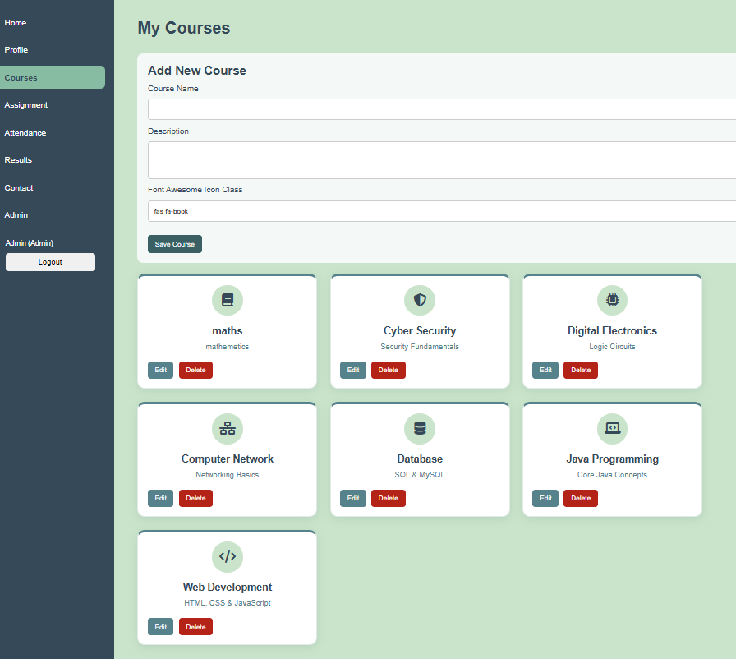
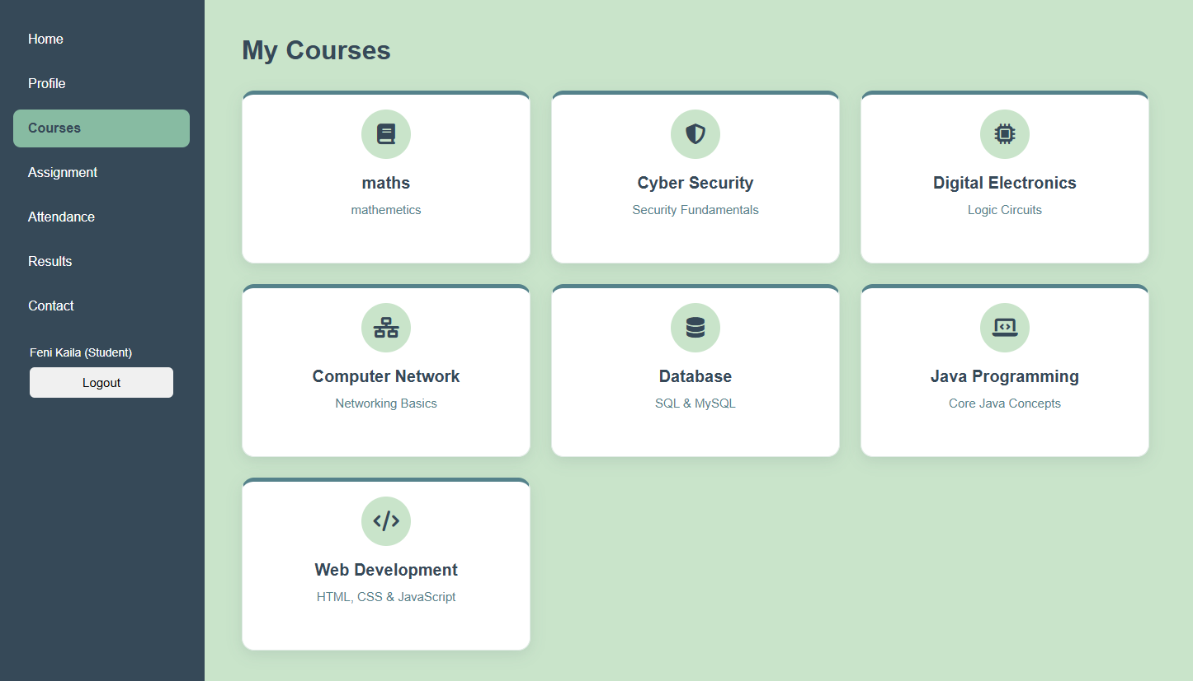
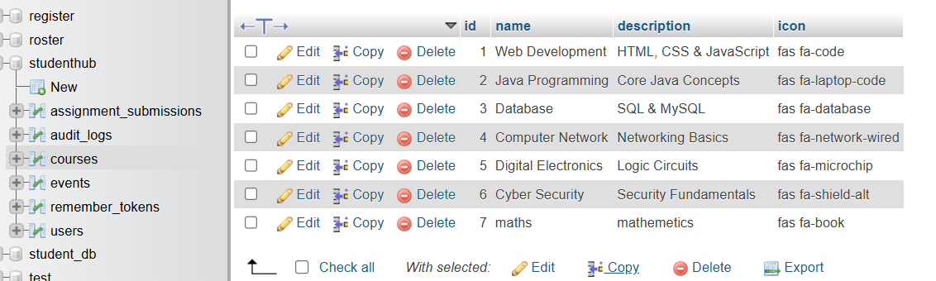

GitHub Repository Link:
https://github.com/fenikaila12/WDF/tree/main/Practical%2013

Challenges Faced:
- Generating valid JSON responses from PHP endpoints.
- Handling GET and POST requests correctly.
- Displaying loading, success, and error states on the frontend.
- Validating user input before database operations.
- Managing communication between the frontend, PHP, and MySQL database.

Learning Outcomes:
- Learned to create PHP endpoints that return JSON responses.
- Understood how to handle GET and POST requests.
- Learned to display loading indicators and success/error messages.
- Gained knowledge of input validation and secure database operations.
- Understood how to exchange data dynamically between the frontend and backend.

Faculty Remarks: (Keep this blank for faculty)

